

CREATE AN EBS AND ATTACH IT TO AN EC2 INSTANCE

By

V. SaranVamsi

[saranvamc.v946@gmail.com](mailto:saranvamc.v946@gmail.com)

Batch- 122

Lecture By:- Mr. Madhukar Reddy

CREATE AN EBS AND ATTACH IT TO AN EC2 INSTANCE

**Elastic Block Store (EBS):**

• Elastic block store is a cloud-based block-storage service designed for amazon elastic cloud compute (EC2) that allows user to store large amount of data in blocks, which works like hard drives.

• They have high durability and low latency performance within selected availability zone.

**Create an EBS volume :**

• Create an EC2 instance in any region you like.

• Now go to on Elastic block store section in EC2 board and click on volumes.

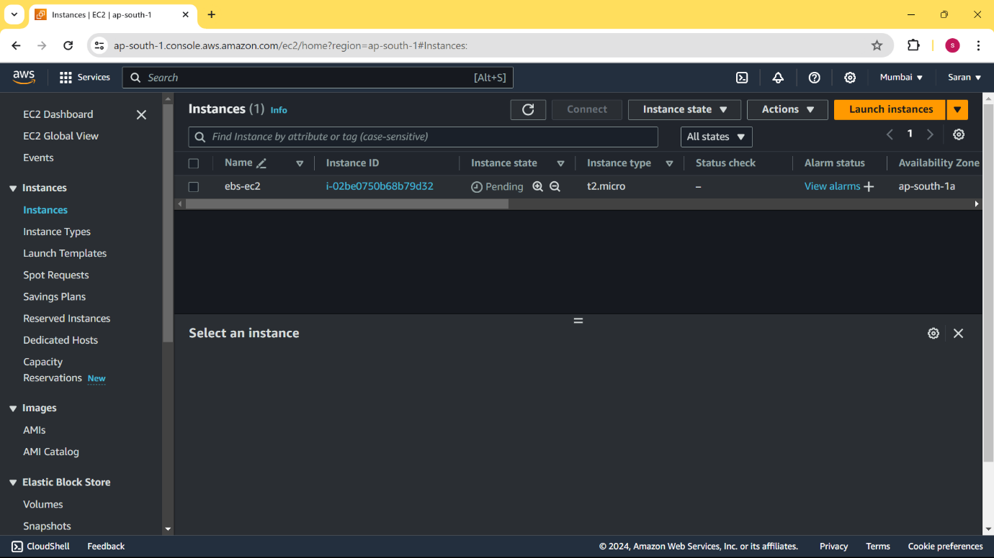

• Now go to volume section and click on create volume and go with the storage type required.

• Lets go with default ssd gp3 and select the region you created your instance. If you created your instance in 1b region then your volume also should be in 1b region.

• Select the size of your storage and click on create.

• Now go to the volumes and you can see your created EBS volume and click on actions and select on attach volume

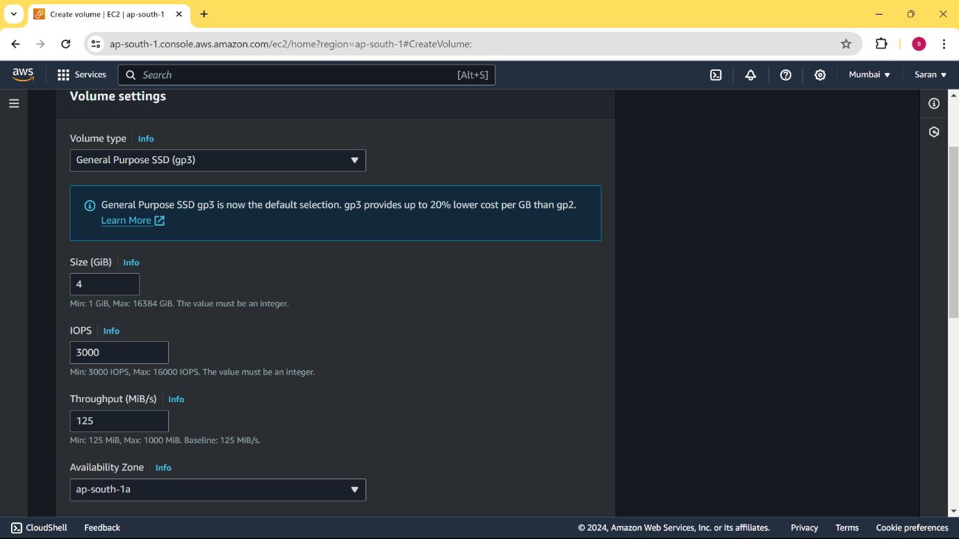

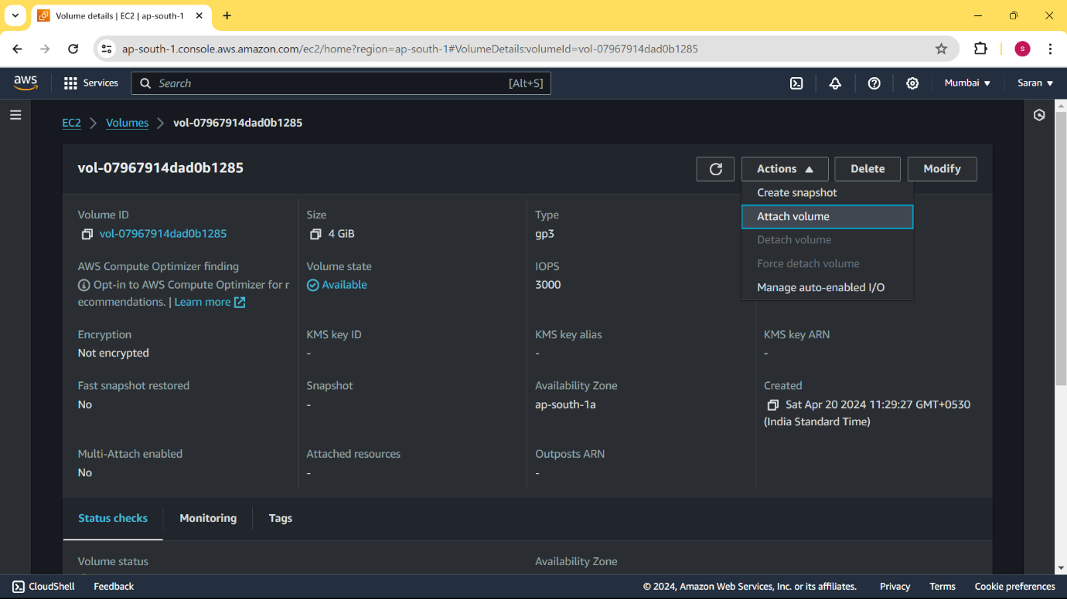

• Now select the instance that you want to attach the EBS and select the device name for the volume.

• After attaching the volume to your instance , go to your ec2 instances and connect to the instance.

• If you give lsblk command you can list out the block storages that are connected to your instances.

• And if you give a command df you can see the disks and storage of your server.

• As you can see the storage which can be seen in lsblk can not be seen in df. So we have to first create a file system for our block storage and mount our storage to a directory.

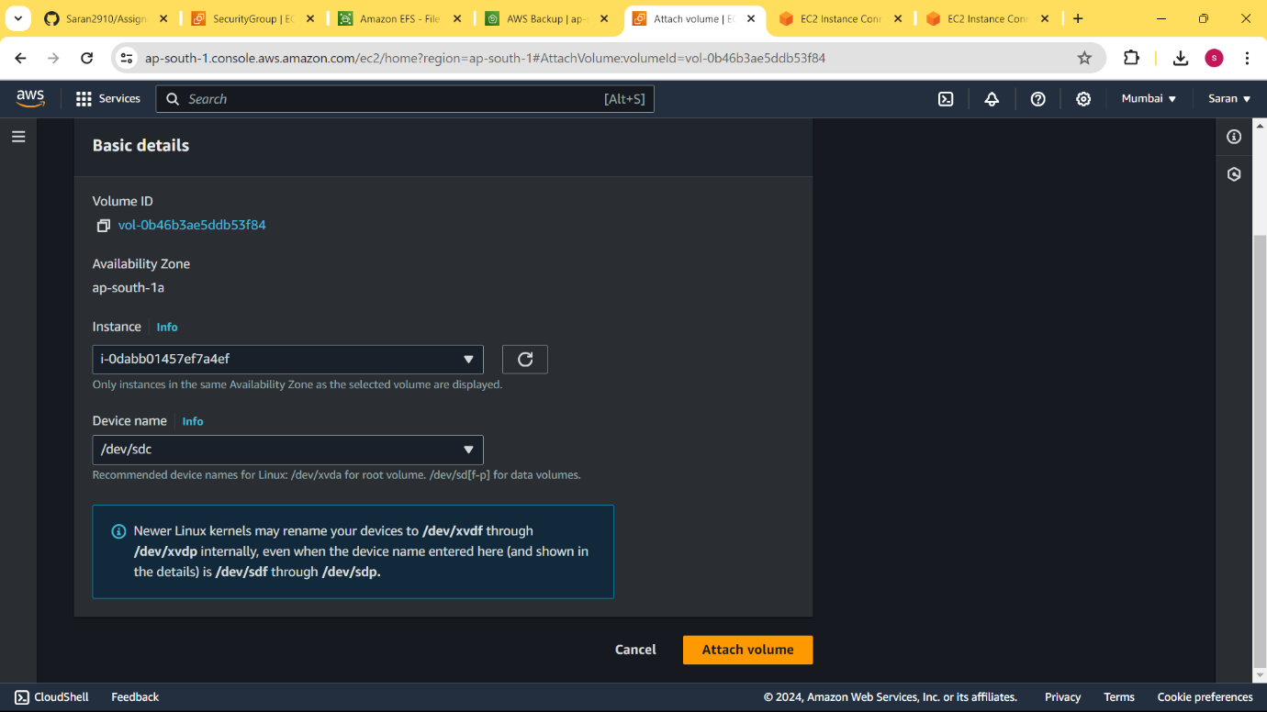

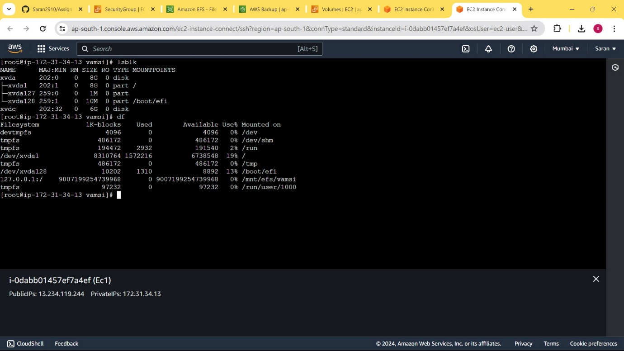

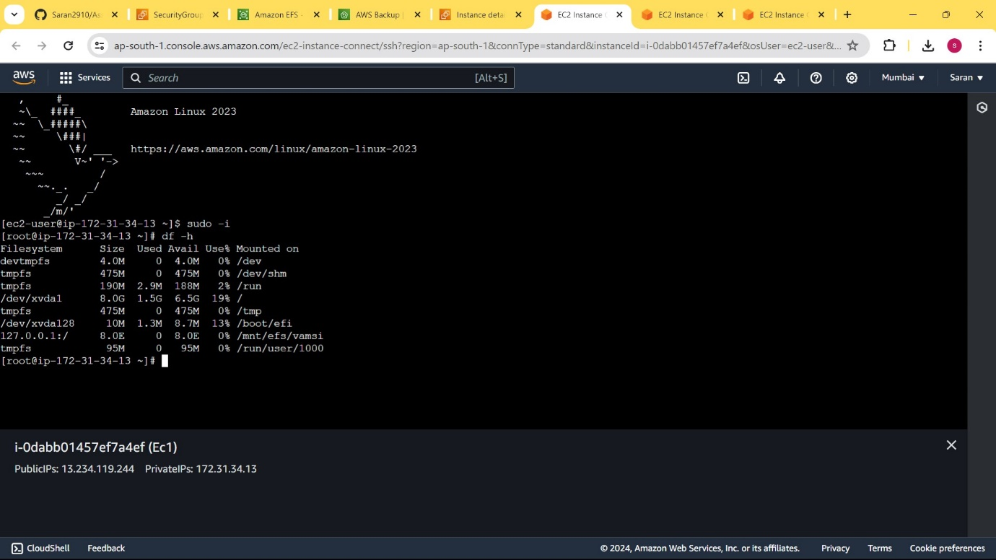

• To ensure that our block store does not have file system we should give a command

file -s /dev/xvdc

• If the output you get is ‘data’ you should create a filesystem to manage the storage with this command

mkfs -t xfs /dev/xvdc

• You can give any filesystem which are recognised by linux namely ext4, reiserFS, XFS, BtrFS, FtFS.

• Here I selected XFS filesystem for my storage.

• Now we should create a directory and mount the storage to that directory with this command

mount /dev/xvdf apps/volume

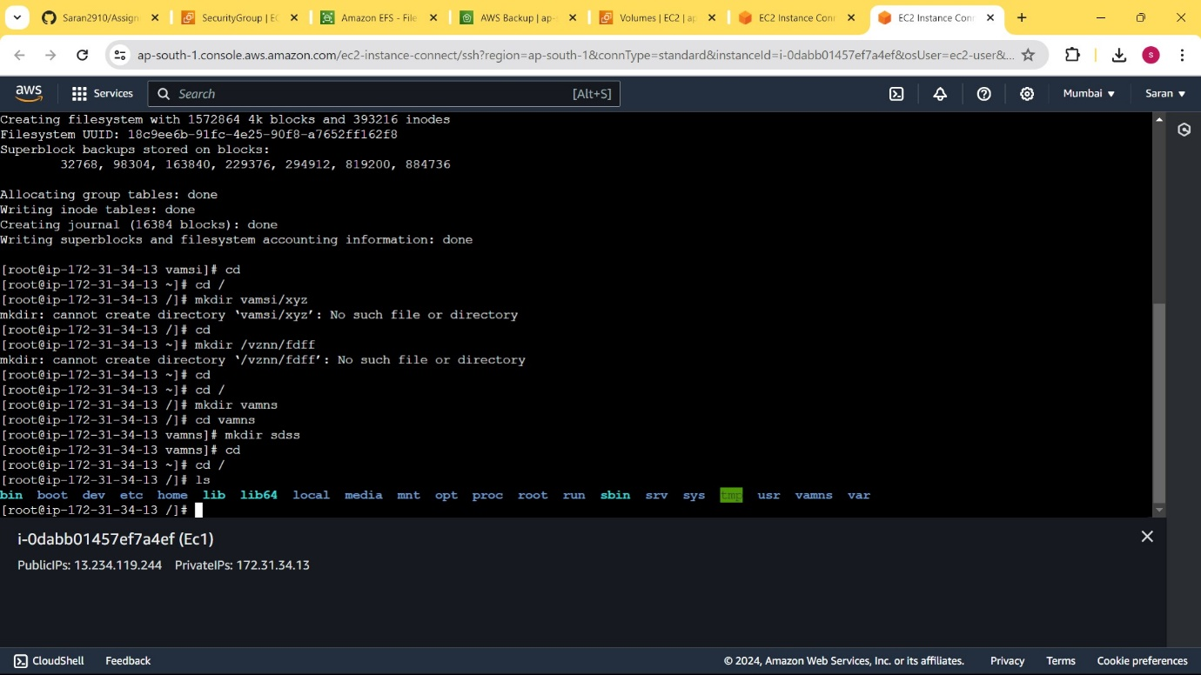

• If you give lsblk and df commands now you can clearly see the storage EBS in your instance.

--------------------------- **THE END**  -------------------------------